Experiment No. 7 and 8
DESIGN AND HARDWARE VERIFICATION OF A SEVEN SEGMENT DECODER
Elliot Gross
Department of Electrical and Computer Engineering
University of Missouri – Rolla
Emg2m9@umr.edu

Computer Engineering 112 Section 3B
Group Members: Terver Maor and Drew Schuermann
Submitted on April 7, 2006

Abstract:
The main purpose of the first part of this lab is first to introduce Karnaugh Maps and seven segment displays and their uses through schematic design. The purpose of the other half of this lab is to verify that the schematic design that was created for the seven segment decoder is correct, and that the correct output is shown. The general method that was approached was first by creating a schematic design based upon the given Karnaugh map to simulate the seven segment decoder. After the schematic design was completed, the actual circuit was built according to the schematic design for the seven segment decoder. Finally, after downloading the bit file to the completed circuit the inputs were tested by changing the inputs on the dip switch to verify that the correct output was showing.

Table of Contents

Abstract……………………………………………………………………………………2

Introduction………………………………………………………………………………..4

Background of the Seven segment decoder......................................……………………...5

Procedure, results, and analysis….………………………………………………………..8

Conclusions………………………………………………………………………………..9

Appendix A.………………………………………………………………………...……10

Appendix B……………………………………………………………………………....11

References………………………………………………………………………………..12

Introduction:
The seven segment decoder design and hardware verification lab’s purpose is to implement the logic of a seven segment decoder. After the design schematic is created using design architect the sheet will be checked for errors, and later implemented using the Quicksim application. After verifying that the design is correct through the simulations on quicksim the schematic will be implemented by creating the circuit and testing the inputs.

Background of the Seven segment decoder:
The seven segment decoder as explained in the lab manual has many different uses for example in a watch or digital clock to name one. The seven segment display can be seen below in figure 1.
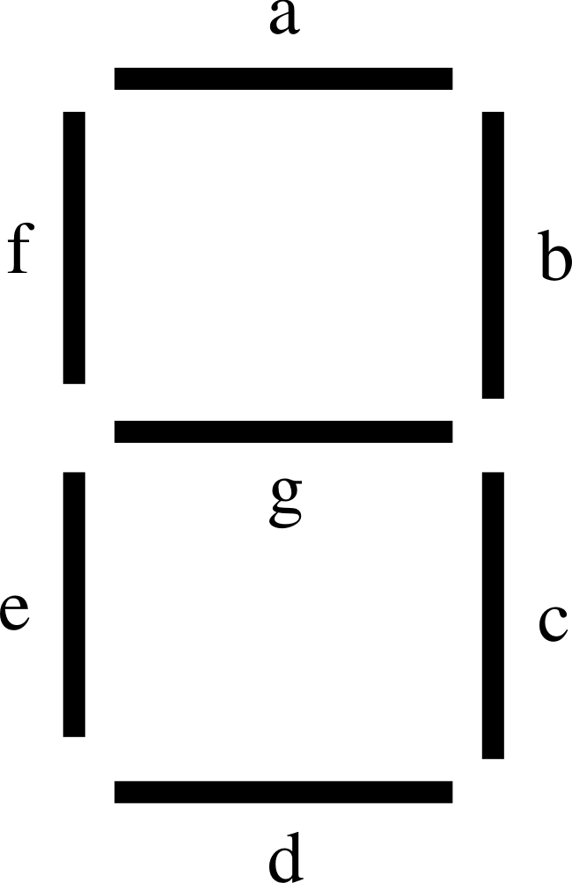
Figure.1 Seven segment decoder orientation [1]

“As explained in the lab manual these seven segment decoders are usually constructed from LEDs. These are usually constructed in either common cathode or common anode displays. Common cathode decoders are called active high since the cathode is attached to the ground and each anode is connected to a resister, and logic “1” turns the segment on. However, in this lab the seven segment decoder is a common anode decoder. Common anode decoders are called active low because the anode is connected to the positive power supply (5v), each segment cathode tied to a segment driver through a resister, and logic “o” turns the segment on.” [2]

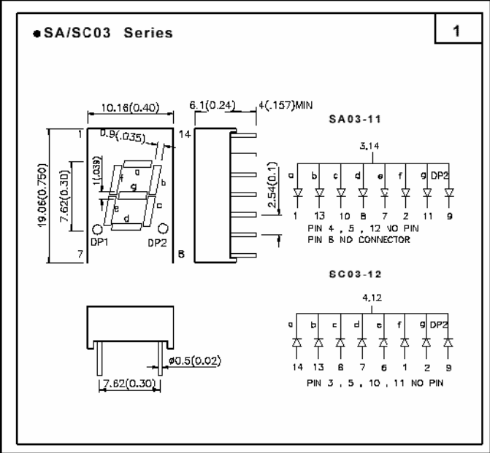
Figure 2 SA03-12HDB7 7 segment display [3]

Hex # | A | B | C | D |  | a | b | c | d | e | F | g
0 | 0 | 0 | 0 | 0 |  | 0 | 0 | 0 | 0 | 0 | 0 | 1
1 | 0 | 0 | 0 | 1 |  | 1 | 0 | 0 | 1 | 1 | 1 | 1
2 | 0 | 0 | 1 | 0 |  | 0 | 0 | 1 | 0 | 0 | 1 | 0
3 | 0 | 0 | 1 | 1 |  | 0 | 0 | 0 | 0 | 1 | 1 | 0
4 | 0 | 1 | 0 | 0 |  | 1 | 0 | 0 | 1 | 1 | 0 | 0
5 | 0 | 1 | 0 | 1 |  | 0 | 1 | 0 | 0 | 1 | 0 | 0
6 | 0 | 1 | 1 | 0 |  | 0 | 1 | 0 | 0 | 0 | 0 | 0
7 | 0 | 1 | 1 | 1 |  | 0 | 0 | 0 | 1 | 1 | 1 | 1
8 | 1 | 0 | 0 | 0 |  | 0 | 0 | 0 | 0 | 0 | 0 | 0
9 | 1 | 0 | 0 | 1 |  | 0 | 0 | 0 | 1 | 1 | 0 | 0
A | 1 | 0 | 1 | 0 |  | 0 | 0 | 0 | 1 | 0 | 0 | 0
B | 1 | 0 | 1 | 1 |  | 1 | 1 | 0 | 0 | 0 | 0 | 0
C | 1 | 1 | 0 | 0 |  | 0 | 1 | 1 | 0 | 0 | 0 | 1
D | 1 | 1 | 0 | 1 |  | 1 | 0 | 0 | 0 | 0 | 1 | 0
E | 1 | 1 | 1 | 0 |  | 0 | 1 | 1 | 0 | 0 | 0 | 0
F | 1 | 1 | 1 | 1 |  | 0 | 1 | 1 | 1 | 0 | 0 | 0

Table 1 Truth Table

The Karnaugh maps for the 7 Segment display are shown as Figure 3.
 | YZ
WX |  | 00 | 01 | 11 | 10
 | 00 | 0 | 0 | 0 | 0
wx | 01 | 0 | 1 | 0 | 1
 | 11 | 1 | 0 | 1 | 1
 | 10 | 0 | 0 | 1 | 0
 |  |  | B
 | YZ
WX |  | 00 | 01 | 11 | 10
 | 00 | 0 | 1 | 0 | 0
 | 01 | 1 | 0 | 0 | 0
 | 11 | 0 | 1 | 0 | 0
 | 10 | 0 | 0 | 1 | 0
 |  |  | A
Figure 3A Figure 3B
 | YZ
WX |  | 00 | 01 | 11 | 10
 | 00 | 0 | 1 | 0 | 0
 | 01 | 1 | 0 | 1 | 0
 | 11 | 0 | 0 | 1 | 0
 | 10 | 0 | 0 | 0 | 1
 |  |  | D
 | YZ
WX |  | 00 | 01 | 11 | 10
 | 00 | 0 | 0 | 0 | 1
 | 01 | 0 | 0 | 0 | 0
 | 11 | 1 | 0 | 1 | 1
 | 10 | 0 | 0 | 0 | 0
 |  |  | C

Figure 3C Figure 3D

 | YZ
WX |  | 00 | 01 | 11 | 10
 | 00 | 0 | 1 | 1 | 0
 | 01 | 1 | 1 | 1 | 0
 | 11 | 0 | 0 | 0 | 0
 | 10 | 0 | 1 | 0 | 0
 |  |  | E
Figure 3E
 | YZ
WX |  | 00 | 01 | 11 | 10
 | 00 | 0 | 1 | 1 | 1
 | 01 | 0 | 0 | 1 | 0
 | 11 | 0 | 1 | 0 | 0
 | 10 | 0 | 0 | 0 | 0
 |  |  | F
Figure 3F

Figure 3G
 | YZ
WX |  | 00 | 01 | 11 | 10
 | 00 | 1 | 1 | 0 | 0
 | 01 | 0 | 0 | 1 | 0
 | 11 | 1 | 0 | 0 | 0
 | 10 | 0 | 0 | 0 | 0
 |  |  | G

The minimum sum-of-products expressions are:

a = A’C’(B XOR D) + AD(B XOR C)

b = BCD’ + ABD’ + ACD + A’BC’D

c = ABC + ABD’ +A’B’CD’
d = A’BC’D’ + AB’CD’+B’C’D + BCD
e = A’(D + BC’) + B’C’D
f = A’B’(D + C) + D(A’C + ABC’)

g = A’(B’C’ + BCD) + ABC’D’

The minimum product-of-sum expressions are:

a = (A + B + C + D’)(A + B’ + C + D)(A’ + B’ + C + D’)(A’ + B + C’ + D’)

b = (A + B’ + C + D’)(A’ + B’ + D)(A’ + C’ + D’)(B’ + C’ + D)
c = (A + B + C’ + D)(A’ + B’ + D)(A’ + B’ + C’)
d = (A + B’ + C + D)(A + B’ + C + D)(B + C + D’)(B’ + C’ + D’)
e = (A + B’ + C)(A + D’)(B + C + D’)
f = (A’ + B’ + C + D’)(A + B + C’)(A + B + D’)(A’ + C’ + D’)
g = (A + B + C)(A + B’ + C’ + D’)(A’ + B’ + C + D)

Procedure, Results, and Analysis:
The project began as first logging into the Unix based Sun Workstation. After logging in the console was opened and a new directory called lab7 was created by using the command mkdir lab7. After navigating to the new directory, lab7, design architect was opened by using the command da in the console. Using the knowledge that was learned from previous labs concerning schematic design, a design schematic named 7seg was constructed as shown in the Appendix A. Next, set the design viewpoint by typing the command pld_dve –s lab7 spartan. After the design viewpoint has been set, we opened quicksim by using the command quicksim 7seg. In quicksim, the trace of the schematic design and the list function were both opened so that the results would be seen after running the simulation. However, before the simulation could be run we opened the pattern generator and altered the duration of each pattern as well as the total number of patterns. For example for signal 1 had a duration of 100 and a total of 16 patterns, signal 2 had a duration of 200 and a total of 8 patterns, signal 3 had a duration of 400 and total of 4 patterns, and finally signal 4 had a duration of 800 and 2 patterns. After completing the use of the pattern generator the simulation was run for a total of 1600ns. After completing this task the list and trace and schematic sheets all were printed out. Next, the symbol from the schematic was generated which would be use to create another sheet that would later relate to the bit file. A copy of the symbol was also printed for records. Next, we created a layout of the top sheet for the SSD design shown in Appendix B. After completing this task our final step was to create a BIT file that would later be programmed onto the hardware to check that our seven segment decoder is functioning properly. The bit file was created by typing the command xmake lab7 spartan xcs05-3-pc84. From here the lab7.dly file and the lab7.par file were printed for records.
In the second part of the lab, the FPGA breadboard was used along with a dipswitch, seven segment display, and a series of resisters (330Ω and 470Ω). A resister was used between the pins off of the FPGA output pin and the LED in order to limit the current through the LED. After that we downloaded the lab7.bit file to the FPGA board. Next, the seven segment decoder was verified to ensure that it was working properly. Finally, the patgen was tested by hooking the patgen to the seven-segment decoder. There the propogation delay was measured. [4]

Conclusions:
In conclusion, after looking at the list, schematic design, and hardware implementation it was seen that the design acted appropriately, and none of the outputs were unexpected. The total design took a total of 4 configurable logic blocks, which were comprised of a total of 32 primitive gates. However, the number of configurable logic blocks is equal to the number of primitive output gates in my design. After completing the hardware implementation of the seven segment decoder it was found that the worse case propagation delay was 3.483ns and the worst delay is from Dipswitch 7 to pin 9.

Appendix A Schematic Design for a Seven Segment Decoder
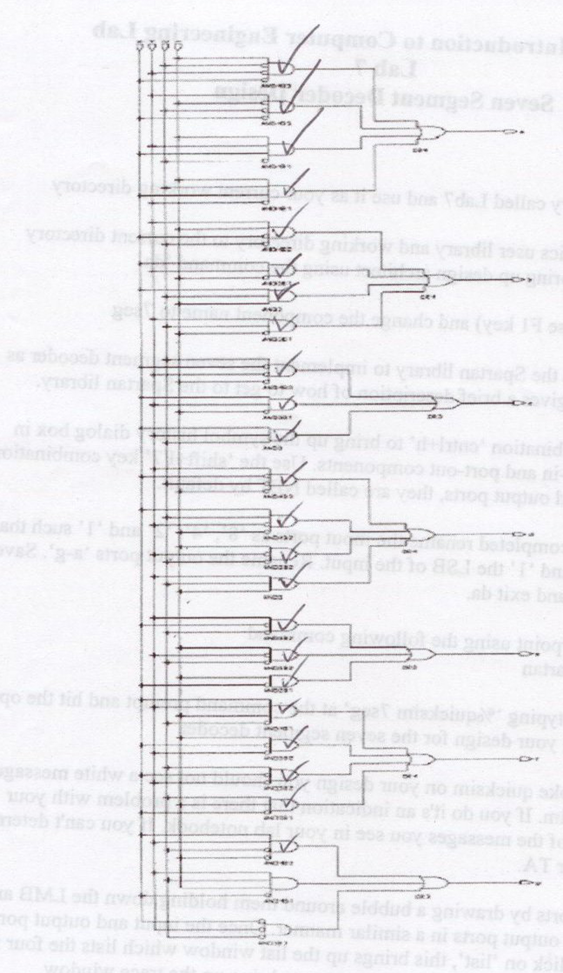
Schematic Design for Seven Segment Decoder[5]

Appendix B Top Level sheet for SSD Design
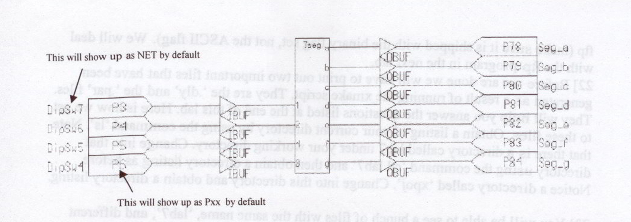
Layout of Top level Sheet for SSD Design[6]

References:

- Colorado State, “7 Segment Decoder gif”, http://www.engr.colostate.edu/~dga/mechatronics/figures/6-34.gif, 1 page
- UMR Electrical and Computer Engineering Department, “Lab Manual for Computer engineering 112”, Spring 2006, 1
- UMR Electrical and Computer Engineering Department, “Lab Manual for Computer Engineering 112”, Spring 2006, 1
- UMR Electrical and Computer Engineering Department, “Lab Manual for Computer Engineering 112”, Spring 2006, 2
- UMR Electrical and Computer Engineering Department, “Lab Manual for Computer Engineering 112”, Spring 2006, 1
- UMR Electrical and Computer Engineering Department, “Lab Manual for Computer Engineering 112”, Spring 2006, 1

